**PostgreSQL Assignment**

**CLUBDATA**

Joins and Subqueries

1. [Retrieve the start times of members' bookings](https://pgexercises.com/questions/joins/simplejoin.html)

**select** bks.starttime **from** cd.bookings bks **inner** **join** cd.members mems **on** mems.memid = bks.memid **where** mems.firstname='David' **and** mems.surname='Farrell';

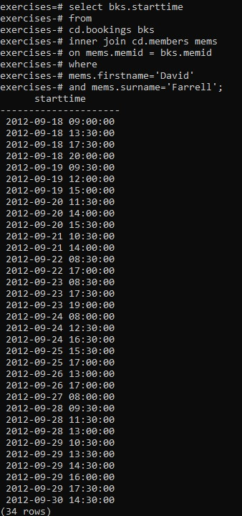

1. [Work out the start times of bookings for tennis courts](https://pgexercises.com/questions/joins/simplejoin2.html)

**select** bks.starttime **as** **start**, facs.name **as** name **from** cd.facilities facs **inner** **join** cd.bookings bks **on** facs.facid = bks.facid **where** facs.name **in** ('Tennis Court 2','Tennis Court 1') **and** bks.starttime >= '2012-09-21' **and** bks.starttime < '2012-09-22' **order** **by** bks.starttime;

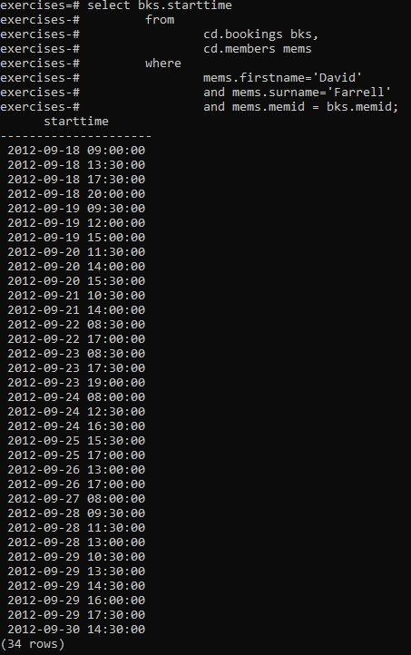

1. [Produce a list of all members who have recommended another member](https://pgexercises.com/questions/joins/self.html)

**select** **distinct** recs.firstname **as** firstname, recs.surname **as** surname **from** cd.members mems **inner** **join** cd.members recs **on** recs.memid = mems.recommendedby **order** **by** surname, firstname;

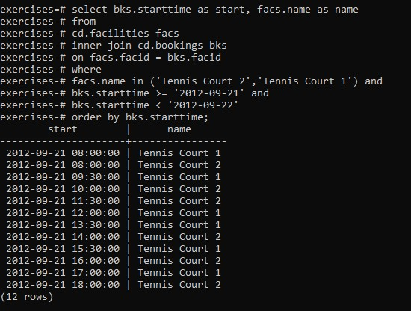

1. [Produce a list of all members, along with their recommender](https://pgexercises.com/questions/joins/self2.html)

**select** mems.firstname **as** memfname, mems.surname **as** memsname, recs.firstname **as** recfname, recs.surname **as** recsname **from** cd.members mems **left** **outer** **join** cd.members recs **on** recs.memid = mems.recommendedby **order** **by** memsname, memfname;

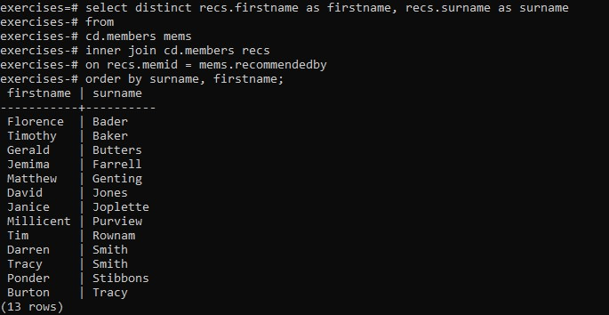

1. [Produce a list of all members who have used a tennis court](https://pgexercises.com/questions/joins/threejoin.html)

**select** **distinct** mems.firstname || ' ' || mems.surname **as** member, facs.name **as** facility **from** cd.members mems **inner** **join** cd.bookings bks **on** mems.memid = bks.memid **inner** **join** cd.facilities facs **on** bks.facid = facs.facid **where** facs.name **in** ('Tennis Court 2','Tennis Court 1') **order** **by** member, facility;

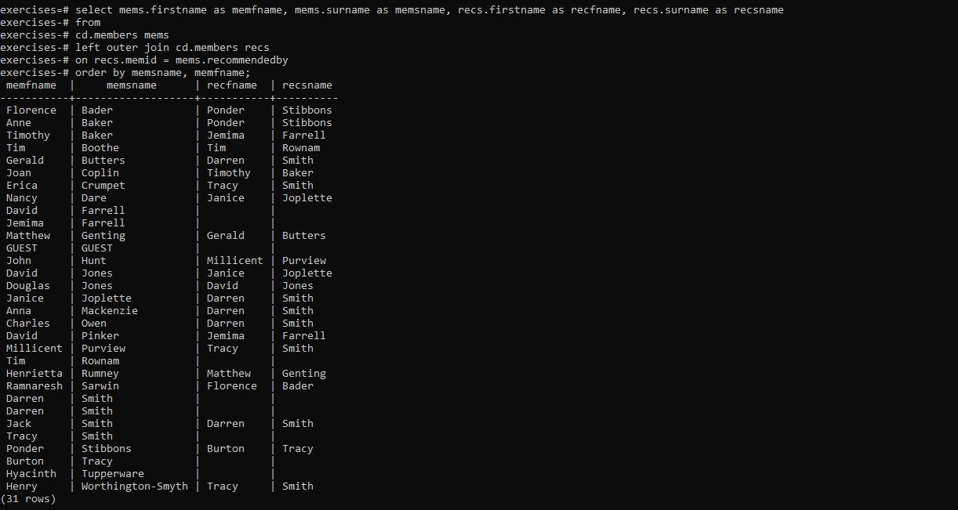

1. [Produce a list of costly bookings](https://pgexercises.com/questions/joins/threejoin2.html)

**select** mems.firstname || ' ' || mems.surname **as** member, facs.name **as** facility, **case** **when** mems.memid = 0 **then** bks.slots*facs.guestcost **else** bks.slots*facs.membercost **end** **as** cost **from** cd.members mems **inner** **join** cd.bookings bks **on** mems.memid = bks.memid **inner** **join** cd.facilities facs **on** bks.facid = facs.facid **where** bks.starttime >= '2012-09-14' **and** bks.starttime < '2012-09-15' **and** ( (mems.memid = 0 **and** bks.slots*facs.guestcost > 30) **or** (mems.memid != 0 **and** bks.slots*facs.membercost > 30) ) **order** **by** cost **desc**;

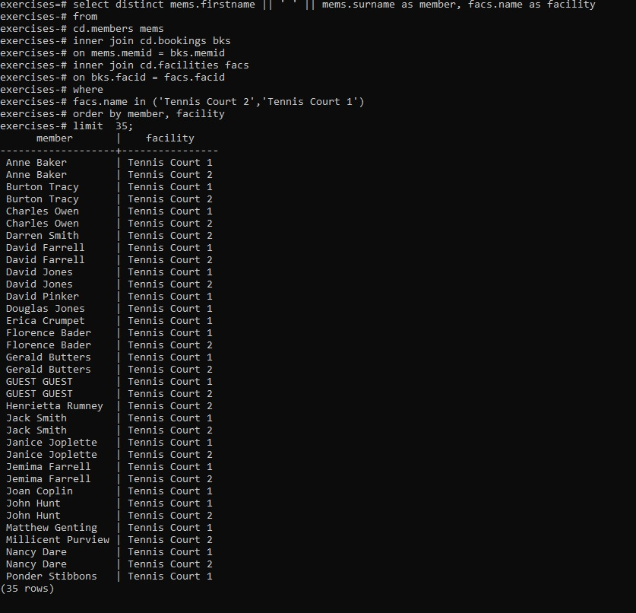

1. [Produce a list of all members, along with their recommender, using no joins.](https://pgexercises.com/questions/joins/sub.html)

**select** **distinct** mems.firstname || ' ' || mems.surname **as** member, (**select** recs.firstname || ' ' || recs.surname **as** recommender **from** cd.members recs **where** recs.memid = mems.recommendedby ) **from** cd.members mems **order** **by** member;

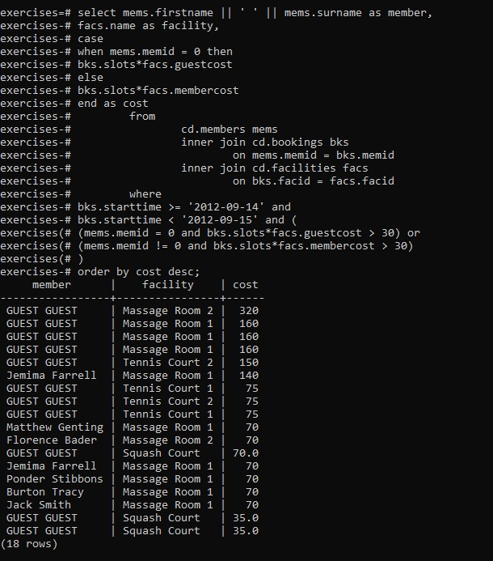

1. [Produce a list of costly bookings, using a subquery](https://pgexercises.com/questions/joins/tjsub.html)

**select** member, facility, cost **from** ( **select** mems.firstname || ' ' || mems.surname **as** member, facs.name **as** facility, **case** **when** mems.memid = 0 **then** bks.slots*facs.guestcost **else** bks.slots*facs.membercost **end** **as** cost **from** cd.members mems **inner** **join** cd.bookings bks **on** mems.memid = bks.memid **inner** **join** cd.facilities facs **on** bks.facid = facs.facid **where** bks.starttime >= '2012-09-14' **and** bks.starttime < '2012-09-15' ) **as** bookings **where** cost > 30 **order** **by** cost **desc**;

